**Domain adaptative sentiment analysis**

**Using Bidirectional LSTM**

Zhouying Wang

A Thesis presented for the degree of

Master of



Department of Computer Science

Durham University

United Kingdom

August 2020

Abstract

The task of detecting sentiment from text faces challenges especially arising from the varying domains. Because of the solo reliance on training data,

In this thesis, we compare the models in domain adaptative sentiment analysis and present the Bidirectional LSTM model capable of effectively detecting the sentiment in same domain and cross domain. First, utilising the . Second, to address the limitation of

Keyword:

Declaration

I declare that all assessed work to be submitted for my degree will be the results of my own work except where group work is involved. In the case of a group project, the work will be prepared in collaboration with other members of the group. In all other cases, material from the work of others will be suitably acknowledged and all quotations and paraphrasing will be suitably indicated.

Contents

Introduction 1

1.1 Key concept 1

1.2 Thesis Contributions 2

1.3 Thesis Scope and Structure 2

Literature review 3

2.1 General overview of the area 3

2.2 Theories 3

2.3 Related studies 3

2.4 gaps 5

Research design 6

3.1 Data description 6

3.2 Data cleaning 7

3.3 Research methodology 9

Sentiment analysis models experiments and results 11

4.1 Machine learning models 11

4.2 Supervised Deep learning model 12

4.3 Semi-supervised deep learning model 16

Bidirectional LSTM 20

5.1 Introduction 20

5.2 Proposed model architecture 20

5.3. Results on same domain sentiment analysis 20

5.4 Results on cross domain sentiment analysis 21

5.5 further analysis 25

Conclusion 26



Introduction

With evolution of data mining technologies, the Internet is serving as a universal and cost-effective source for extracting the user opinions. Sentiment is fundamental to attain insights. Sentiment analysis is one of the most prolific research directions in Natural Language Processing (NLP). There are many researches about sentiment analysis in specific domain and all achieved desirable performance. Due to inherent ambiguities and variability of semantic expressions, the task of detecting sentiment from text faces challenges especially arising from the varying domains. Sentiment detection and classification can be applied widely into the different fields to learn about the sentiment information and attain insights from the enormous. However, because of the solo reliance on training data, algorithm works well in the laboratory often bear significant performance loss when it comes to the realistic world application since it crosses specific domain boundaries. The sentiment analysis suffers from the domain dependency problem.

The goal of the domain adaptative sentiment analysis is to reduce the domain dependency without at the cost of sentiment detection accuracy by means of analysing linguistic data. Despite extensive research, development of sophisticated algorithms, upgrade in computing power, it remains a challenge to reduce the sensitivity of the sentiment analysis to the domain boundaries without sacrificing the performance.

## **1.1 Key concept**

**1.1.1 Sentiment Analysis (SA)**

Sentiment analysis in NLP refers to identifying the expressed opinions of the given text. SA can be categorized into three levels (figure). The basic level is document-level sentiment analysis, which takes the whole document as a unit and further classifies into sentiment polarity such as positive and negative. The sentence-level sentiment analysis further classifies sentence into subjective and objective types. On a more granular scale, SA can also be conducted on aspect level which is also known as feature-based sentiment analysis. The aspect-level sentiment analysis task summarises identifying the aspects in sentences, classifying the aspect into positive or negative polarity and clubbing the sentiment values. While the binary classification into positive and negative is commonly used in research, sentiment can also be classified into positive, negative and neutral three class and into multi-class feelings, for example joy, fear, anger, depress and so on.

**Negative polarity**

**Positive polarity**

Figure1.1 Positive and negative sentiment polarity example

**1.1.2 Domain Adaptation (DA)**

Domain referred as a set of text that are closely related to specific topic. When sentiment analysis involves multi-domain, information transferring is inevitable from one domain to another domain. With solo reliance on training source domain, the performance of sentiment analysis models on target domain decreases for crossing the domain boundary. The knowledge learned in source domain requires solution to transfer to target domain. Hence, domain adaptative sentiment analysis been invested into considerable efforts to solve the domain dependency problem.

Figure 1.2 Domain discrepancy in sentiment analysis

## **1.2 Thesis Contributions**

This thesis mainly contributes to the accurate cross domain sentiment classification based on limited size of labelled training data.

A variety of neural network-based models are proposed to explore an algorithm to improve the sentiment analysis performance. By comparing the performance of different models and different source domain and target domain, the outperforming model (Bi-LSTM) is selected and the relationships between domains are also be investigated.

To address the limitation of inadequate learning of the model, we utilised the Bidirectional Long Short-Term Memory (Bi-LSTM) model to training the input both considering the previous context and future context by processing the input sequence from left to right as well as the reverse direction, which is particularly effective for small size dataset with cross domain sentiment analysis accuracy up to 99.26%.

## **1.3 Thesis Scope and Structure**

The goal of this thesis is to propose and implement the effective sentiment analysis model on cross domain dataset. The thesis presents the research project structured into following parts towards the goal.

Chapter 2 sets the background knowledge by introducing the existing sentiment analysis methods in domain adaptation and state-of-art algorithms. By means of reviewing the domain adaptative sentiment analysis literature

Chapter 3 demonstrates the research methodology of the project including the pre-processing of the text, the

Chapter 4 explores the performance of machine learning models and neural network-based models in same domain sentiment analysis. By comparison, the outperforming

Chapter 5 address the inadequate learning of text from small size of labelled training dataset by incorporating Bi-LSTM model

Finally, Chapter 6 concludes and lays out promising directions for the future work.

Literature review

## **2.1 General overview of the area**

In the early studies, sentiment analysis is mainly based on Lexicon. With the development of NLP techniques, more and more studies work on learning-based sentiment analysis. While supervised learning methods performs well on specific

domains, its accuracy decreases significantly when it transfers to the new domains. Domain Adaptation (DA) methods address the sensitivity problems when sentiment analysis across various domains. However, DA techniques remain limited in accuracy and robustness due to data sparsity.

## **2.2 Theories**

There are two main research directions in the studies of domain adaptation in recent years involves domain translation and pseudo-label-based methods.

Domain translation is trying to search for a meaningful correspondence between the source domain and target domain. The task is to generate analogous data in target domain using the source domain data.

Pseudo-label-based methods build upon the centre idea of self-training, creating learning process to caste the problem with noisy labels. Pseudo-label-based methods train using labelled and unlabelled data simultaneously, the model can be undated by iteratively propagating labels. Pseudo-label-based methods are often focusing on image classification in recent studies.

## **2.3 Related studies**

Lots of studies explore approaches to address the domain discrepancy gap. It is a widely used way to extract domain-invariant features to minimize the gap of marginal distribution of source and target domain. Blitzer, J [1] first creating framework to extracting pivot features using Structural Correspondence Learning with Mutual information (SCL-MI). In the later studies, Maximum Mean Discrepancy (MMD) methods gained popularity and was further researched. Inspired by MMD, Yan, H. *et al.* [20] bring up that the adaptation may have class weight bias across domains due to changes between classes distribution in target domain and prior distribution in source domain. They proposed a Weighted Maximum Mean Discrepancy (WMMD) by introducing class-specific auxiliary weights to reweight the source samples. Cvpr, A. and Id, P. [4] further point out that it would lead to the mismatch of the local misalignment if only consider the marginal distributions gap in domain level without taking the alignment in category level into consideration. They proposed a hierarchical gradient synchronization method to model the relationship between the category-level and domain-level distribution pieces, constructing the class-wise, group-wise and domain alignment to address this issue.

It is worth noting that the studies are mainly based on the deep convolutional neural networks (CNN), the non- CNN based UDA models still remain to be investigated. Though the MMD studies achieved success in improving the performance, they are still tackling closed-set scenario which is unrealistic since target domain may contain samples of classes unseen in source domain. Busto and Gall [2] is one of the early attempts to deal with the realistic open-set scenario. Pan, Y. *et al* [16] introduced Self-Ensembling with Category-agnostic Clusters (SE-CC) model to reveal the typical data space structure of target domain, matching the estimated assignment distribution over clusters to the innated distribution over target cluster. The open-set scenario remains open problem to be solved.

As stated in theories, there is another research direction that works on directly labelling the samples in target domain as pseudo-labels. D. hyun Lee. [5] is one of the early attempts to exploit the self-trained model and tune the model as supervised learning methods. Pan, Y. *et al* [17] build transferrable prototypical networks to utilize the pseudo label self-learning, minimizing the target and source data. However, it should be noted that pseudo-label-learning methods have inherent weakness that the prediction of the pseudo labels may be wrong labels, providing noisy information.

There are also studies focus on other aspects of the domain adaptation which can inspire the research of this project. Lu, Z. *et al.* [12] find using more classifiers result in better performance instead of two classifiers as the existing UDA methods employed. However, the diverse classifiers make the model have higher risk to overfit due to more parameters in the model. In efforts to handle this problem, multivariate Gaussian distribution is can be utilized over weights of classifiers.

These studies all observe performance improvements and deserve deeper analysis and exploration.

## **2.4 gaps**

The recurrent neural network (RNN) a well-studied solution to process variable length input and have long term memory. While CNN is widely used in the study of cross domain sentiment analysis, there are also other deep learning models effective.

Research design

## **3.1 Data description**

The Multi-Domain Sentiment Dataset is collected by Blitzer, J [1]. It contains product reviews taken from Amazon.com from 4 product domains: Kitchen Appliances, Books, DVDs, and Electronics. Each domain has several thousand reviews, but the exact number varies by domain. The dataset has originally binary labelled positive and negative reviews and is separated into the two groups in all domains. There are also unlabelled data in each domain for testing. The dataset includes information about product, reviewer and review text. Amazon Standard Identification Number (ASIN) is a 10-character alphanumeric unique ID for distinguish the products ad Unique ID is the ASIN with the title of review and reviewer such as ‘0312355645: horrible book: mark gospri’. Product name, Product type, Date and Reviewer location are also recorded in the dataset. The rating varies from 1 to 5 stars and the helpful attribute records if other users find the reviews useful. This research project would mainly emphasize on the review text to do the sentiment domain adaptation.

Table 3.1. Dataset information

Figure 1. samples count in four domains

## **3.2 Data cleaning**

In order to efficiently pre-process the data, the datafile requires transformation with xml as the original file type of the dataset. Positive reviews are encoded as label 1 and negative reviews are labelled 0. The four domains each contains 1,000 positive reviews and 1,000 negative reviews. With perfectly balanced data in all four domains, there is no need to leverage the data over two class.

Figure 2. Labels count in each domain

Using NLTK packages, the reviews sentence can be split into words, converted into lower case and remove the punctuation so that the text can be better understood and trained by the models. While removing the stop words is a universe approach in NLP, *Andrius Mudinas* proposed that the stop words would influence the performance of sentiment analysis. For enhancing the model performance, the stop words are kept in this project.

As some models require the same shape inputs, the length of input sequence should be set in order to train the models. Known as common method, padding the input sequence according to the max length of the input is applied. Although the maximum word length of the review can be computed with maximum length 3227 in Books domain, 1415 in DVD domain, 918 in Electronics domain and 958 in Kitchen appliance domain, it may result in losing efficiency with a vast increase in input size and complexity. As presented in figure , the length of reviews are most concentrated in range 50 to 200. The mean length of input sequence in four domain is 128 and the medium length in four domain are 105.5, 104, 72.5 and 65 respectively. To improve the efficiency without losing much semantics of the input, the length of the reviews is set to be 120 words maximum and 2 words minimum.

Figure Lengths of input sequences in four domains

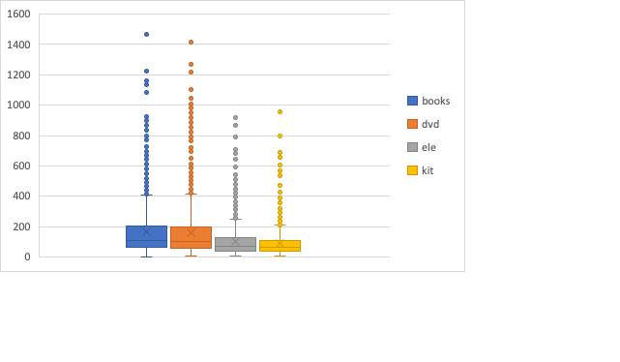

## **3.3 Research methodology**

The model experiments start from the same domain sentiment analysis with 1700 training samples and 300 testing samples in all four domains separately. The Supervised learning models are the first to apply. Machine learning models include random forest model and logistic regression model and deep learning models involve convolutional neural network (CNN) and LSTM. Then we also considered semi-supervised pretrained model for the enhancement.

Among the models, our model, the Bi-LSTM model, achieves a competitive accuracy in same domain analysis. To explore the improvement direction to cross domain adaptative sentiment analysis, the analysis on Bi-LSTM is carried out with training on all 2000 samples in one domain and testing on 2000 samples in another domain which means there will be 12 situations including Books to DVD, Books to Electronics, Books to Kitchen appliance, DVD to Books, DVD to Electronics, DVD to Kitchen appliance, Electronics to Books, Electronics to DVD, Electronics to Kitchen appliance, Kitchen appliance to Books, Kitchen appliance to DVD and Kitchen appliance to Electronics. To facilitate the sentiment classification performance, we further discussed the Bi-LSTM model architecture and the results of both same domain sentiment analysis and cross domain sentiment analysis.

The model evaluation is based on model accuracy and model loss on test data in both same domain sentiment analysis and cross domain sentiment analysis.

Figure Research design

Sentiment analysis models experiments and results

## **4.1 Machine learning models**

Machine learning methods are ubiquitous in classification problem. Though there are limitations when the feature space is complex and the kernel functions are computationally expensive. The random forest model and logistic regression model are selected as an attempt to use machine learning to address the sentiment analysis problem.

Using tf-idf vectorizer, the review text can be converted to vectors and trained in the Machine learning models. As demonstrate in the table and figure, the test accuracy of random forest model in single domain range from 0.61 to 0.66. The performance of logistic regression model is better than random forest model with test accuracy in the range of 0.78 and 0.83. The accuracy in Books domain is relatively lower and the accuracy in Electronics and Kitchen appliance is slightly higher comparing the performance of two models in four different domains.

However, with limited information carried regarding the inter-dependencies between the words in sentences, the performance of the two models are not satisfying. The error of the Random forest model prediction on test data is up to 39% and the error of logistic regression model prediction is up to 22%.

|  |  |  |
| --- | --- | --- |
|  | Random Forest Model | Logistic Regression Model |
| Books | 0.61 | 0.78 |
| DVD | 0.65 | 0.78 |
| Electronics | 0.66 | 0.80 |
| Kitchen Appliance | 0.65 | 0.83 |

Table 4.1. Accuracy of Machine Learning models

Figure 4.1. accuracy of two models in four domains

## **4.2 Supervised Deep learning model**

Domain adaptation can be divided into supervised, semi-supervised and unsupervised according to the scale of labelled data in target domain. Supervised domain adaptative sentiment analysis requires training data to be labelled and in specific domain, completely relying on training source domain dataset. Semi-supervised learning is an effective way to leveraging unlabelled data to improve the domain adaptation performance. Unsupervised learning is more suitable for large scale of data which offers an inexpensive and less time-consuming ways to implement the domain adaptation. The focus of this project is to improve the domain adaptation performance for small size dataset. Hence, the supervised learning models and semi-supervised models are the emphasis of the model experiments.

a. Convolutional Neural Network (CNN) model

The CNN model is a popular model in sentiment analysis studies for its independence from prior knowledge and human effort in feature design. CNNs employ filters within convolutional layers to transform data to pass to the next layer. The CNN consists of an input layer, output layer, convolutional layer and a pooling layer. Utilizing the tokenizer of keras pre-processing text, the data can be passed to input layer without further pre-processing. The activation function of convolutional layer is RELU which is commonly used.

The CNN applied in this project uses Conv1D layer with relu activation function and max pooling layer as figure 4.2 presented. The hyper parameters are optimized with binary crossentropy as the loss function, learning rate 0.01, Adam optimizer ,128 batch size and 100 epochs.

Figure 4.2 CNN model composition

However, the CNN model does not perform well in same domain sentiment analysis for the relatively low quantity of training and test samples. As figure show, the training accuracy experience a rapid rise to 1, while the test accuracy is stagnant around 0.5 which means the model is not learning effectively in the process of training with model loss down to 0 substantially on training part and sharply increase on testing part. The CNN model faces the challenge of overfitting.

|  |  |  |
| --- | --- | --- |
|  | Training accuracy | Test accuracy |
| Books | 1.00 | 0.49 |
| DVD | 1.00 | 0.53 |
| Electronics | 1.00 | 0.49 |
| Kitchen appliance | 1.00 | 0.52 |

Table 4.2. Accuracy of CNN model in four domains

Figure 4.3 Model accuracy and model loss of Books domain

Figure 4.4 Model accuracy and model loss of DVD domain

Figure 4.5 Model accuracy and model loss of Electronics domain

Figure 4.6 Model accuracy and model loss of Kitchen appliance domain

b. Long Short-Term Memory (LSTM) model

The recurrent neural network (RNN) is very effective in sentiment analysis. The generic architecture of RNNs is depicted in figure 4.7. RNN allows connecting to previous context to the present task, processing the input sequence sequentially.

Figure 4.7 RNNs generic architecture.

While basic RNNs are computationally expensive and parameter intensive as the gap between the relevant information and the present task grows, LSTM networks as a special RNNs model are capable of learning long-term dependencies with a unique LSTM unit and chain-like structure. The LSTM model can capture the relevant information in the sentential context even when it is remote from the target word. As presented in figure 4.8, the long-short term memory (LSTM) unit with the forget gate allows highly non-trivial long-distance dependencies to be easily learned which matches the review text sentiment analysis task.

Figure 4.8 LSTM networks with LSTM unit

The LSTM model is defined as figure 4.9 shows with binary crossentropy loss function and adam optimizer.

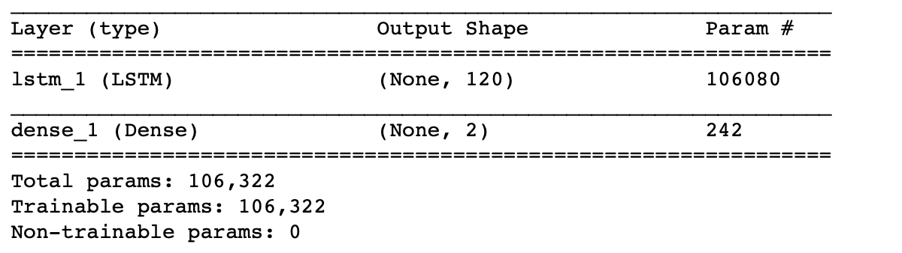

Figure 4.9 LSTM model composition

Though the LSTM model is a suitable choice for the sentiment analysis task theoretically, the performance is not ideal as expected. With test accuracy 0.60 in books domain, 0.50 in DVD domain, 0.61 in electronics domain and 0.52 in kitchen appliance domain, the accuracy of LSTM model prediction is only slightly higher than CNN model. Similar to CNN model, the limitation of LSTM model is overfitting and inadequate learning on source domain. As presented in figure, the LSTM model loss in four domains rises gradually differing from the abrupt increase of CNN model loss.

|  |  |  |
| --- | --- | --- |
|  | Training accuracy | Validation accuracy |
| Books | 0.98 | 0.60 |
| DVD | 0.91 | 0.50 |
| Electronics | 0.96 | 0.61 |
| Kitchen appliance | 0.71 | 0.52 |

table 4.3 Accuracy of LSTM model in four domains

Figure 8. Model accuracy and model loss of Books domain

Figure 9. Model accuracy and model loss of DVD domain

Figure 10. Model accuracy and model loss of Electronics domain

Figure 10. Model accuracy and model loss of Kitchen appliance domainA close up of a map

Description automatically generated

## **4.3 Semi-supervised deep learning model**

The pre-trained model is a common approach for semi-supervised learning in natural language learning. The model is based on pretrained language model (LM) whose weights are initialized using 'wikitext-2' dataset. With package GlounNLP, the pretrained LM model can be loaded. After representing the input words by embeddings, the embeddings can be passed to a two-layer LSTM. Following the encoder layer, the model consists of an average pooling layer, followed by the output layer using sigmoid activation function as figure shows.

Figure Pretrained model architecture

Pretrained LM

The pre-trained model does not perform well in all four domains though the test accuracy is improved slightly compared to the LSTM model. Table demonstrates the training and test accuracy of pre-trained model. The model performs better in books domain than in other domains.

|  |  |  |
| --- | --- | --- |
|  | Training accuracy | Validation accuracy |
| Books | 1.00 | 0.64 |
| DVD | 1.00 | 0.55 |
| Electronics | 1.00 | 0.60 |
| Kitchen appliance | 1.00 | 0.62 |

Table 4.4 Accuracy of pre-trained model in four domains

Figure 15. Model accuracy and model loss of Books domain

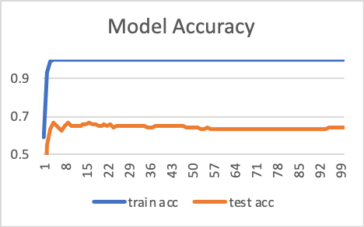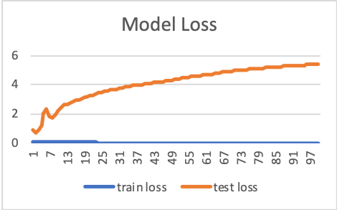

Figure 16. Model accuracy and model loss of DVD domain

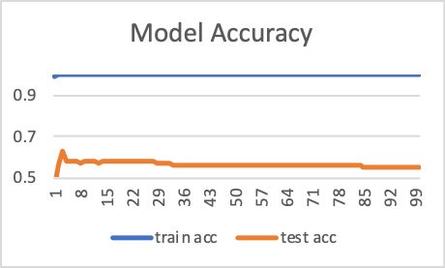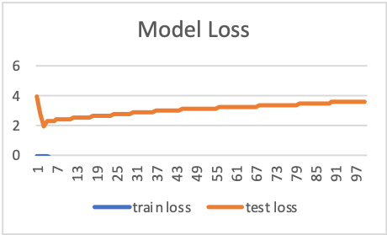

Figure 17. Model accuracy and model loss of Electronics domain

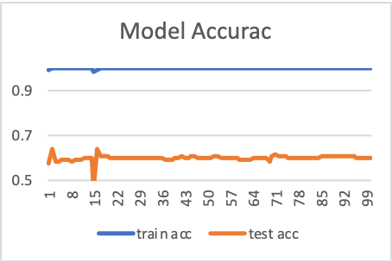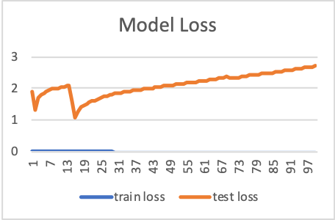

Figure 18. Model accuracy and model loss of Kitchen Appliance domain

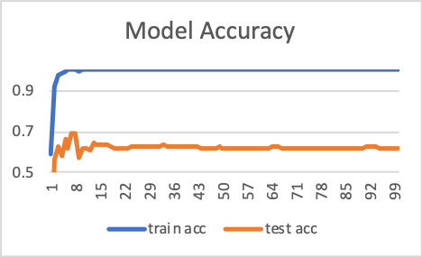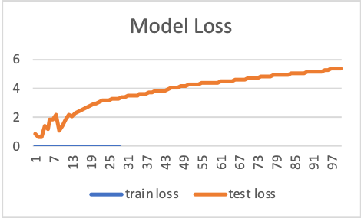

**4.4 Model comparison**

In all four domains, apart from our model, the logistic regression model outperforms other models.

Different Matching domain

|  |  |  |  |  |
| --- | --- | --- | --- | --- |
| Models | Test accuracy | | | |
| Books | DVD | Electronics | Kitchen appliance |
| Random forest | 0.61 | 0.65 | 0.66 | 0.65 |
| Logistic regression | 0.78 | 0.78 | 0.80 | 0.83 |
| CNN | 0.49 | 0.53 | 0.49 | 0.52 |
| LSTM | 0.60 | 0.50 | 0.61 | 0.52 |
| Pre-trained | 0.64 | 0.55 | 0.60 | 0.62 |
| Our model (Bi-LSTM) | 0.98 | 0.99 | 0.99 | 0.99 |

Bidirectional LSTM

## **5.1 Introduction**

To address the inadequate learning limitation in the models, the bidirectional LSTM (Bi-LSTM) is proposed by.

The generic architecture of Bi-LSTM is illustrated in figure 5.1. By means of processing the input sequence in both direction (left to right and right to left), the model can both learn the previous context (left side) and the future (right side). The parameters of these two layers are also separate. The main idea is to

The merge mode

## **5.2 Proposed model architecture**

**layers**

**hyper parameter**

## **Figure LSTM model composition**

## **5.3. Results on same domain sentiment analysis**

The bidirectional LSTM model improves the validation accuracy sharply.

Table 5. Accuracy of bidirectional LSTM model in four domains

|  |  |  |
| --- | --- | --- |
|  | Training accuracy | Validation accuracy |
| Books | 0.9932 | 0.9836 |
| DVD | 0.9947 | 0.9906 |
| Electronics | 0.9946 | 0.9883 |
| Kitchen appliance | 0.9975 | 0.9899 |

Comparison

|  |  |  |  |  |
| --- | --- | --- | --- | --- |
| Models | Test accuracy | | | |
| Books | DVD | Electronics | Kitchen appliance |
| Baseline (LSTM) | 0.60 | 0.50 | 0.61 | 0.52 |
| Pre-trained LSTM | 0.64 | 0.55 | 0.60 | 0.62 |
| Our model (Bi-LSTM) | 0.98 | 0.99 | 0.99 | 0.99 |

Figure 11. Model accuracy and model loss of Books domainA screenshot of a cell phone

Description automatically generated

Figure 12. Model accuracy and model loss of DVD domain

Figure 13. Model accuracy and model loss of Electronics domain

Figure 14. Model accuracy and model loss of Kitchen Appliance domain

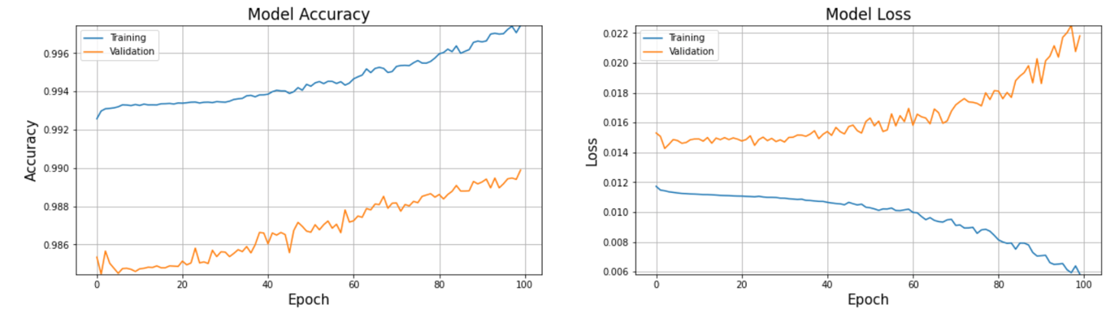

## **5.4 Results on cross domain sentiment analysis**

The bidirectional LSTM performs well in cross domain sentiment analysis.

Domain similarity

|  |  |  |
| --- | --- | --- |
|  | Training accuracy | Validation accuracy |
| Books to DVD | 0.9925 | 0.9916 |
| Books to Electronics | 0.9943 | 0.9916 |
| Books to Kitchen appliance | 0.9978 | 0.9916 |
| DVD to Books | 0.9973 | 0.9920 |
| DVD to Electronics | 1.0000 | 0.9916 |
| DVD to Kitchen appliance | 1.0000 | 0.9919 |
| Electronics to Books | 0.9996 | 0.9923 |
| Electronics to DVD | 1.0000 | 0.9926 |
| Electronics to Kitchen appliance | 1.0000 | 0.9918 |
| Kitchen appliance to Books | 0.9988 | 0.9918 |
| Kitchen appliance to DVD | 0.9987 | 0.9919 |
| Kitchen appliance to Electronics | 0.9978 | 0.9922 |

Books to DVD

Books to Electronics

Books to Kitchen appliance

DVD to Books

DVD to Electronics

DVD to Kitchen appliance

Electronics to Books

Electronics to DVD

Electronics to Kitchen appliance

Kitchen appliance to Books

Kitchen appliance to DVD

Kitchen appliance to Electronics

## **5.5 further analysis**

Conclusion

Domain adaptation is a crucial task in sentiment analysis. With reliance on training source domain

Reference

page5image33529920page5image33530112page5image33530304page5image33530496page5image33530688page5image33530880